**Lab Exam Exercise**

**Objective:**Set up and configure a network topology using RIP and OSPF routing protocols in Cisco Packet Tracer. Customize the network by assigning each computer a name and an IP address using the last three digits of your roll number.

**Procedure:**

1. **Network Topology Design:**
   * Create a topology that includes:
     + 10-12 computers distributed across two LANs.
     + Use two or more switches.
     + At least two routers connected via a WAN link.
   * Each computer must be assigned a name with the format: PC_RollNumber (e.g., PC_123).
2. **IP Address Configuration:**
   * Assign IP addresses to the computers in each LAN.
   * The last three digits of each student's roll number must be used for the last octet of the computer’s IP address (e.g., 192.168.1.RollNumber).
   * Use a different subnet for each LAN (e.g., 192.168.1.0/24 for LAN 1 and 192.168.2.0/24 for LAN 2).
3. **Routing Protocols Configuration:**
   * Configure one router with RIP v1.
   * Configure the other router with OSPF.
   * Ensure communication between LANs using these protocols.
4. **Packet Tracer Configuration Steps:**
   * Add devices and create connections between them.
   * Configure IP addresses on the computers, switches, and routers.
   * Set up static routes or enable RIP/OSPF on the routers.
   * Ensure correct routing between the two LANs and that data can be transmitted between networks.
5. **Simulation:**
   * Use Cisco Packet Tracer’s simulation mode to test message transmission.
   * Ensure a message can be successfully transmitted from one network to another.
6. **Documentation and Submission:**
   * **Procedure Documentation:** Create a step-by-step procedure that includes:
     + Network design.
     + IP address assignment.
     + Routing protocol configuration.
   * **Screenshots:** Capture the topology and successful message transmission.
   * **Packet Tracer File:** Save the .pkt file with your completed configuration.
   * **GitHub Submission:** Upload all files (procedure document, screenshots, and .pkt file) to a GitHub repository named with Lab 2 exam.
   * Submit the repository link to the instructor.

**Screenshot:**

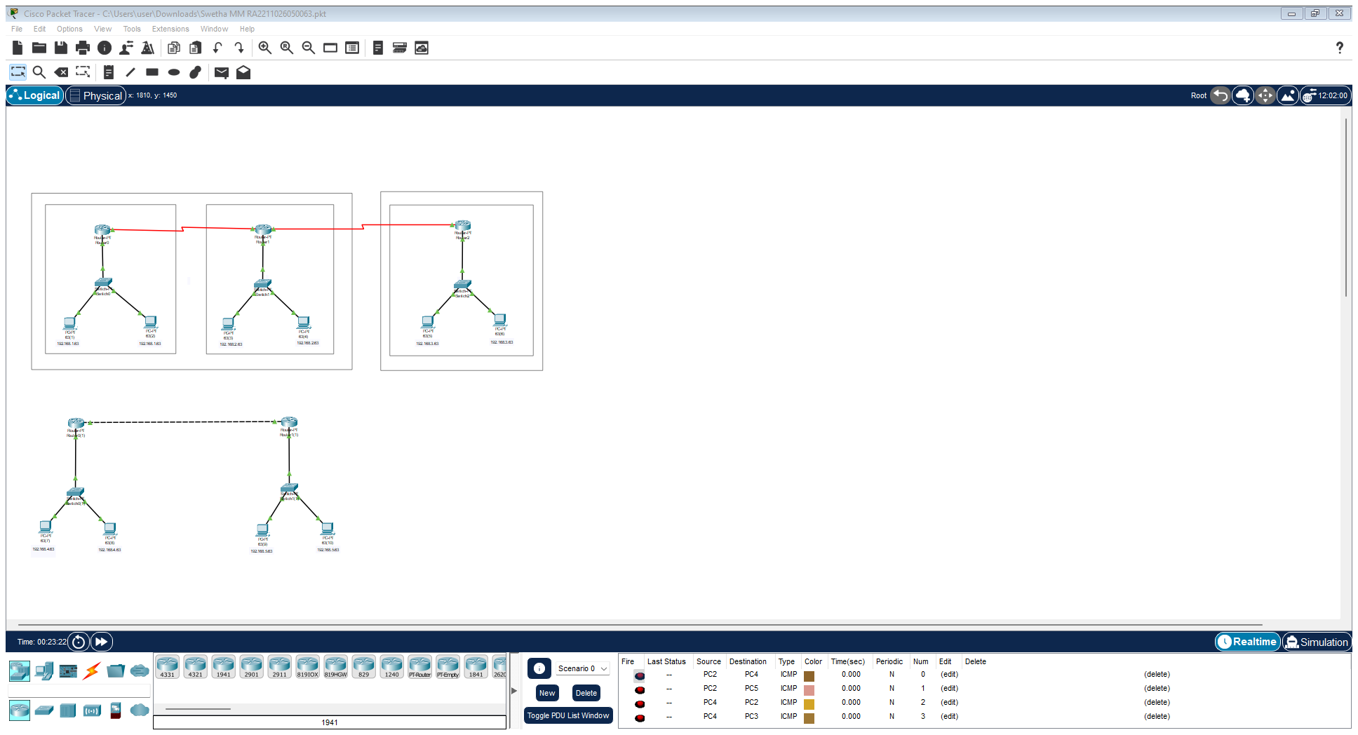

Github link: https://github.com/swethamurugan96/Cisco-Packet-Tracer/https://github.com/swethamurugan96/Cisco-Packet-Tracer/